Foxes Cycle B 21 – 22
 | Autumn 1 | Autumn 2 | Spring 1 | Spring 2 | Summer 1 | Summer 2
Book | 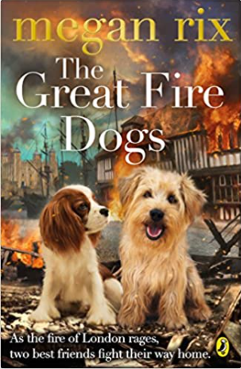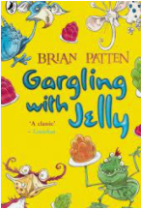 | 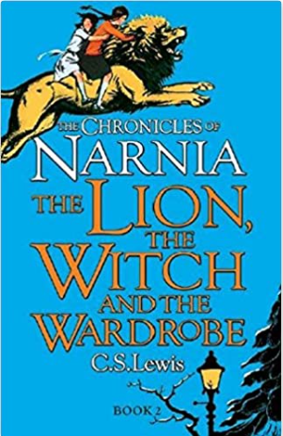 | 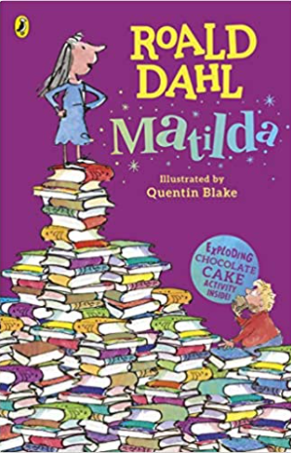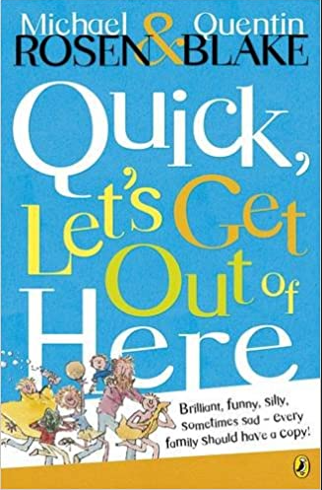 | 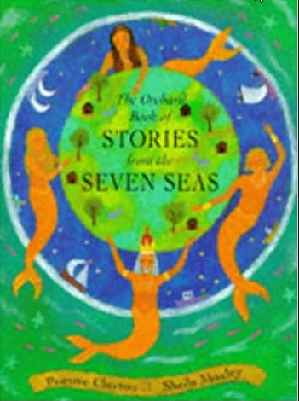 | 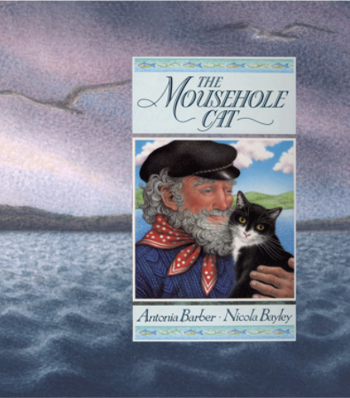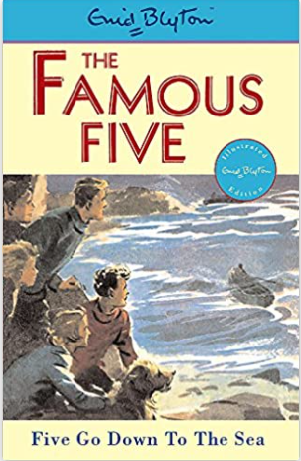 | 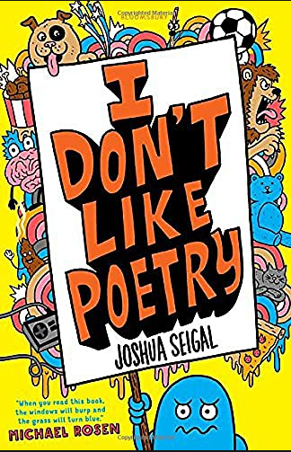
History / Geography | History: Did the Great Fire make  London a better or worse place?  Should we celebrate Bonfire Night ?  (changes beyond living memory) | Geography: Where on earth are we?  (2d/3d maps; latitude & longitude, location of continents & countries) | History: What can we learn about changes over time at Longleat from the evidence that remains?  (local study) | Geography: What are the wonders of our world?  (comparison of human & physical features of area of UK to non-European & European countries) | History: How have sea-side holidays changed? (changes in living memory; an aspect of British history over time | Geography: Do we like to be beside the sea-side?  (topographical features of UK; fieldwork)
Science | Young Gardeners  How seeds and bulbs grow into mature plants. Pants need water, light and a suitable temperature to grow and stay healthy | Squash, Bend, Twist, Stretch  Masterchefs  some materials can be changed by squashing, bending, twisting and stretching plus investigation into materials used for chef hats or cooking utensils. | Forces and Magnets | . Healthy Me  Importance for humans of exercise, eating the right amounts of different types of food, and hygiene. | How does your garden grow?  Parts of flowering plants, water transportation, life cycle flowering plants | Plants in the science curriculum map to ensure all Y3 objects covered but if all have been covered could do Our Local Environment (habitats and food changes). This topic was not done in Otter’s on previous cycle in 2021.
Religious Education | What do Christians learn from the creation story?  Creation UC | What is the trinity?  God/Incarnation | How can Brahman be everywhere and in everything?  Hinduism | Why do Christians call the day Jesus died ‘Good Friday’.  Salvation UC | Would visiting the River Ganges feel special to a non-Hindu?  Hinduism | What do Christians believe God is like?  God UC
PSHE | Being Me in my World | Celebrating Difference | Dreams and Goals | Healthy Me | Relationships | Changing me
Art / Design | Sparks and Flames  Sculpture and paint |  | Earth Art  Painting |  | LS Lowry  Drawing and paint
Sports Coach | football | gymnastics - pathways | netball | dance | outdoor & adventurous activity – communication & tactics | Rounders
Class Teacher PE | gymnastics – symmetry & asymmetry | ball skills | hockey | swimming | tennis | Athletics
Computing | We are safe researchers  Researching a topic  networks | We are animators  Creating a stop-motion animation | We are who we are  Creating a presentation using PowerPoint |  | We are zoologists  Data collection | We are opinion pollsters  Data collection
Music | London’s burning | Songs for Remembrance/Christmas | Recorder  instrumental tuition | Recorder  instrumental tuition | Storm: Benjamin Britten  Listening & review; composition | Production: Performance  Singing
Visitors/visits / other | Making the guy for village bonfire | Singing at O2, London. | Visit to Longleat | ‘Stations of the Cross’ at church |  | Visit to Weymouth or similar  Whole school production
 | Autumn 1 | Autumn 2 | Spring 1 | Spring 2 | Summer 1 | Summer 2
Book | 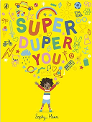  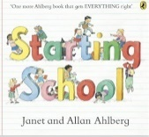  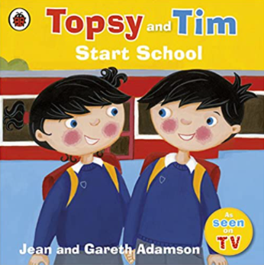 | 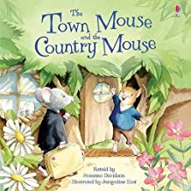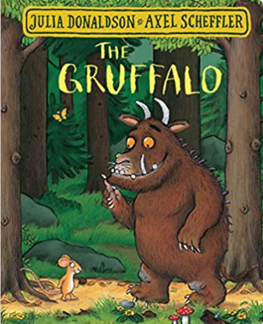 | 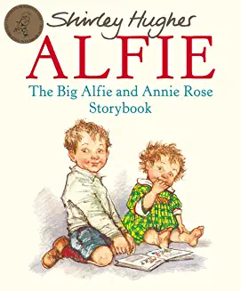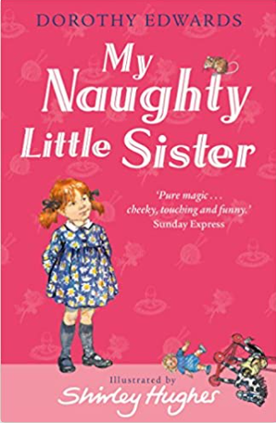 | 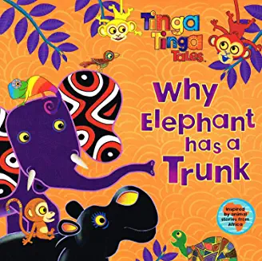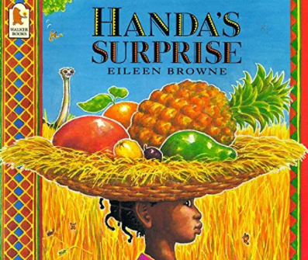 | 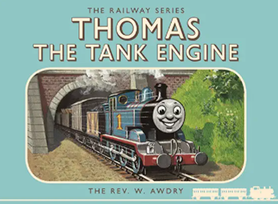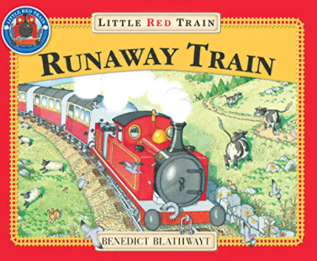 | 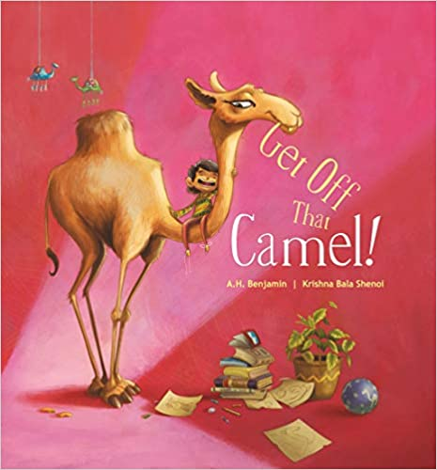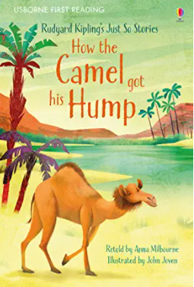
History / Geography |  | Geography: What’s it like in Heytesbury?  Local study | History: What was life like when my grandparents were children? (homes & school)  History within living memory | Geography: Where in the world do these people live? Timbuktu Mali WHY?  Small area of UK cf non-European country | History: How did Stephenson’s ‘Rocket’ change travel?  Events beyond living memory that are significant | Geography: Where do our favourite animals live? Bears, camels Not convinced Canada & bears is right for cold areas.  Hot & Cold places
Science | EYFS – Into the woods  Year 1  Plants where we live.( Identify and classify plants locally)  Seasonal change: Sept/Oct | Dough Babies – EYFS  Who am I (Body parts and senses)  Celebrations- food (structure of plants, edible bits) | EYFS –Pirates : floating and sinking, sorting  Y1 Materials – link to homes and history topic. | EYFS – Dinosaurs  Y1 Plants and animals where we live part 2 (birds and animal classification)  Seasonal change : March/April | EYFS – The potting shed  Y1 - Young gardeners Y2 subject knowledge ((How seeds and bulbs grow into mature plants. Pants need water, light and a suitable temperature to grow and stay healthy | EYFS - Food of the seasons  Y1 Healthy Me Y2 subject knowledge ( importance for humans of exercise, eating the right amounts of different types of food, and hygiene)  Seasonal change: July
Religious Education | What makes people special?  Special people: Christianity,  Judaism D | Why do Christians perform nativities at Christmas?  Incarnation UC | How do people Celebrate?  Celebrations: Islam D | Why do Christians put a cross in an Easter garden?  Salvation UC | What can we learn from stories?  Islam, Judaism D | What is the good news that Jesus brings?  Gospel UC
PSHE | - Being Me in my World | Celebrating Difference | Dreams and Goals | Healthy Me | Relationships | Changing Me
Art / Design | Colour Creations  Painting | DT | African Art  Painting | DT | Henri Rousseau  Painting landscapes | DT
Sports Coach  Complete PE | Gymnastics: moving | Locomotion  Jumping  How is this a progression from T1? | Ball Skills  Hands | Dance The Zoo | Locomotion Dodging | Athletics  Running, jumping
Class Teacher PE  Complete PE | Locomotion:  Jumping | Gymnastics:  wide, narrow, curled | Dance Water  Why this theme? Because of EYFS floating & sinking? | Ball Skills : feet | Swimming | Athletics  Throwing
Computing | We are treasure hunters  Using programmable toys | We are TV chefs  Filming the steps of a recipe | We are digital artists  Creating art inspired by artist | We are publishers  Finding images using the web | We are rhythmic  Producing a talking book with sound effects | We are detectives  Creating a greetings card digitally
Music | Music Express Y1: Ourselves/ number | Songs for Christmas (via singing worship) | BBC traditional tales: Anansi - Africa |  | Music Express Y1 Travel  Performance /beat
Visitors/visits / other | Rev Trudy: special people: Christianity  Walk around school field; river bank | Fieldwork in village  School nurse | Grandparents

Music: much adaptation needed. Only taught tin terms 2 4 6. Geography & history topics have changed so music topics need to change to link in. Computing – no longer part of EYFS curric – what do they ned to be able to do to access Y1 computing? Y1 themes need to be reduced and re-ordered.
 | Autumn 1 |  | Autumn 2 | Spring 1 | Spring 2 | Summer 1 | Summer 2
Book | 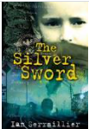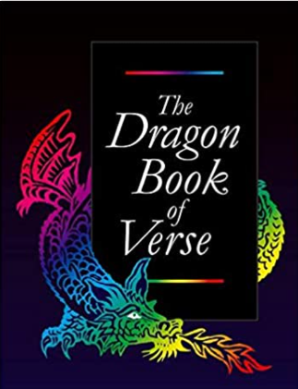 |  | 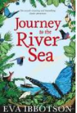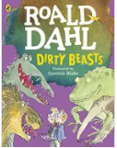 | 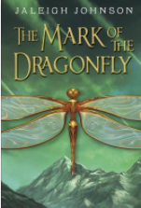 | Mia Angelou; BAME poets | 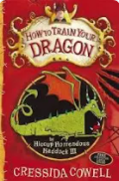 | 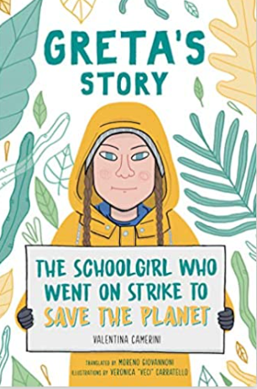
History / Geography | What was the impact of WW1 and WW2 on the local area? |  | What is life like in the Amazon? | How much did the Ancient Egyptians achieve? | How will our world look in the future? (needs to be changed – too boring – housing, amenities) | Would the Vikings do anything for money? | Are we damaging our world?  sustanability
Science | Living Things  Grouping, classifying, identifying living things. Environmental change |  | Cycle of Life  Animal live cycles, reproduction in animals and plants | Classifying living things  Classification plants, animal and microorganisms | Science in action: The Big Build  Scientific enquiry revisiting materials knowledge | Out of this World  Solar system, day and night | Light
Religious Education | Creation and Science: conflicting or complimentary?  Creation and Fall |  | Was Jesus the Messiah?  Incarnation | What is the best way for a Hindu to show commitment to God?  Prayer and Worship Hinduism D | What would Jesus do?  Gospel | Do beliefs in karma, samsara and moksha help Hindus lead a good life? Practices and ways of life Hinduism D | When Jesus left, what was the impact of Pentecost?  Kingdom of God UC: Digging Deeper
PSHE | - Being Me in my World |  | Celebrating Difference | Dreams and Goals | Healthy Me | Relationships | Changing Me
Art / Design | In Flanders Fields  Sculpture |  | DT | Famous Fashions  Drawing | DT | A sense of Place  Painting – perspective | DT
Sports Coach | Invasion: Bee Netball |  | Gymnastics:  matching and mirroring | Invasion:  Basketball | OAA:  problem solving | OAA:  orienteering | Striking & Fielding:  cricket
Class Teacher PE | Swimming |  | Invasion:  Tag rugby | Dance:  Carnival | Net/Wall  Badminton | Striking & Fielding:  Rounders | Athletics: competitions
Computing | 3 week  E-safety focus | We are artists  Fusing geometry and art |  | We are adventure gamers  Creating an interactive adventure using presentation software |  | We are publishers  Creating a yearbook or magazine
Music | Wartime songs: Glen Miller  performance; listening & review |  | Pitch it  ? | BBC Trailblazers Hans Zimmer Earth  Listening & Review | Ukulele  performance | Composition  Pentatonic scale  composition | Ukulele  performance
MFL
Visitors/visits / other | Village remembrance service |  |  | Dorchester Museum visit | Spring concert
Cycle C Badgers 22-23

Badgers A 23-24
 | Autumn 1 |  | Autumn 2 | Spring 1 | Spring 2 | Summer 1 | Summer 2
Book | 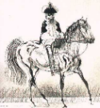  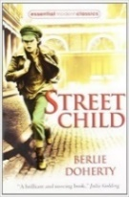 |  | 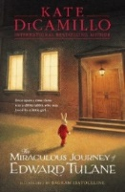  The Highwayman | 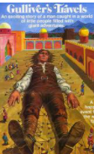  Windrush Poetry:  John Agard; Benjamin  Zephaniah | 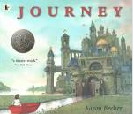 | 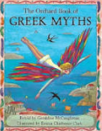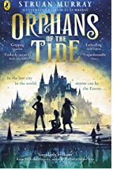
History / Geography | History: How has crime and punishment changed over time?  British history over time  To be reviewed – not needed as hist objs covered in Foxes if sea-side unit is done in cycle B and again in ‘Windrush’ topic this year but children got a lot out of it. Also local link – Millicent Fawcett, suffragette from Salisbury; feel suffragettes important to understanding Bristish Culture. Also links to Ancient Greece & democracy/votes. |  | Geography: How different is The United Sates of America to the United Kingdom?  Human & physical geography of North America cf UK | History: What was the impact of ‘The Windrush’ for different people?  To be reviewed – not needed as hist objs covered in Foxes if sea-side unit is done in cycle B and again in ‘Crime & Punishment’ topic this year. However part of our cultural understanding – Ofsted develop point. | Geography: Where does all our stuff come from?  Land use, economic activity including trade links, and the distribution of natural resources | History: What have the Ancient Greeks done for us? | Geography: How and why do places change?  Regions of the UK: South-West & South East London
Science | Power it up - Electricity |  | Power it up - Electricity | What’s that sound? | Lets get moving: gravity /friction | Lets get moving: pulleys /levers/gears | Evolution and inheritance
Religious Education | Creation and Science: conflicting or complimentary Creation and Fall  Shouldn’t this go in the term with science evolution? |  | Was Jesus the Messiah?  Incarnation UC | What is the best way for a Hindu to show commitment to God?  Prayer and Worship Hinduism D | What would Jesus do?  Gospel | Do beliefs in karma, samsara and moksha help Hindus lead a good life? Practices and ways of life Hinduism D | When Jesus left, what was the impact of Pentecost?  Kingdom of God UC digging deeper
PSHE | Being Me in my World |  | Celebrating Difference | Dreams and Goals | Healthy Me | Relationships | Changing Me
Art / Design | Charles Fazzino – cityscapes  Sculpture |  | DT | Express yourself  Drawing: portrait | DT | Paul Klee Study  Painting | DT
Sports Coach | Invasion:  football |  | Gymnastics: bridges | Invasion:  hockey | OAA:  problem solving | OAA:  orienteering | Striking & Fielding:  Rounders
Class Teacher PE | Swimming |  | Invasion:  Bee Netball | Dance:  Space  They need to do this they are doing space in science ie cycle C. Or does it mean they are learning about using space as they dance? | Net/Wall | Striking & Fielding  cricket | Athletics:  throwing and jumping  running
Computing | 3 week  E-safety focus | We are software developers Developing a simple educational game |  | We are game developers  Developing an interactive game |  | We are makers  Testing and writing our own micro:bit project | We are cryptographers  Cracking codes
Music | Trailblazers: Florence Price  Listening & Review |  | African drumming  Performance  composition | BBC Music: Treasure Island  Listening & Review | BBC Music: Treasure Island  Listening & Review | Ukulele  performance | Ukulele  performance
MFL | C’est moi!  All about me- facts  Ask and answer questions:  name age |  | Story making :Cher Zoo  Animals, Adjectives | C’est moi - hobbies  Express preferences like/dislike | A l’école  Subjects, routines, preferences  Cultural differences | En vacances – on holiday  What is the content summary? | Le temps, Monsieur Le Loup: What’s the time Mr Wolf?  Tell time – analogue  Daily routines
 | Autumn 1 | Autumn 2 | Spring 1 | Spring 2 | Summer 1 | Summer 2
Book | 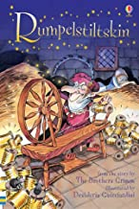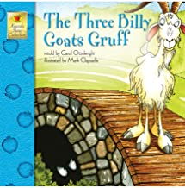 | 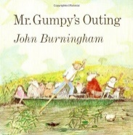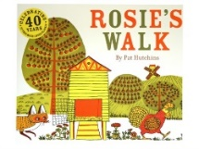 | 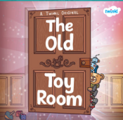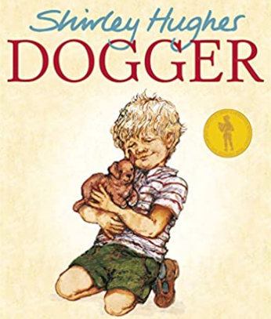 | 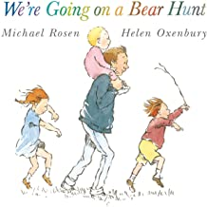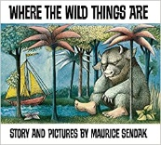 | 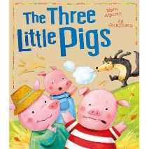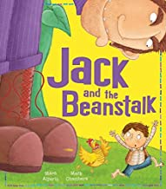 | 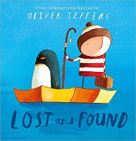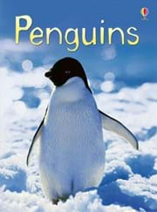
History / Geography |  | Geography: What’s it like in Heytesbury?  Local study | History: What was life like for my grandparents when they were children? (toys)  History within living memory | Geography: Where in the world do these people live? Timbuktu Mali WHY?  Small area of UK cf non-European country | History: How did the first flight change the world?  Events beyond living memory that are significant | Geography: Where do our favourite animals live? (penguin & spider monkey)  Hot & Cold places
Science  The order of these now needs to change as hist/geog has changed. Also new EYFS curric. | EYFS Sound Collectors  Y1 Who am I? | EYFS Light Magic  Y1 Celebrations Light  Seasonal change Nov/Dec | EYFS: Slimy things  EYFS Frozen  Y1 Polar Places  Seasonal change Jan/Feb | EYFS: Mud, glorious mud  Y1 Plants & Animals where we live  Our local Area? | EYFS Into the woods  Y1 Our Local Environment | EYFS Whatever the weather  Y1 On Safari  Seasonal change May/June
Religious Education | Who made the World?  Creation UC | Why does Christmas matter to Christians?  Incarnation UC | What makes places special?  Special places D  Christianity, Judaism, Islam | Why does Easter matter to Christians?  Salvation UC | Is Shabbat important to Jewish children?  Judaism Shabbut D | What do Christians believe God is like?  God UC
PSHE | - Being Me in my World | Celebrating Difference | Dreams and Goals | Healthy Me | Relationships | Changing Me
Art / Design | Mark Making  Drawing | DT | Animal Art  Painting | DT | Colour creations  Painting: (Primary and secondary colours) | DT
Sports Coach | Gymnastics  high, Low, over, under | Locomotion  running | Ball Skills  feet | Dance  Nursery Rhymes  Will this fit with the English? | Locomotion:  jumping | Athletics  Running, sports day races
Class Teacher | Locomotion:  walking | Gymnastics:  body parts | Dance growing | Ball Skills : hands | Swimming | Athletics  Throwing, sports day races
Computing | We are treasure hunters  Using programmable toys | We are TV chefs  Filming the steps of a recipe | We are digital artists  Creating art inspired by artist | We are publishers  Finding images using the web | We are rhythmic  Producing a talking book with sound effects | We are detectives  Creating a greetings card digitally
Music | Special people  Beat, tempo | Songs for Christmas | Music Express Toys  Texture |  | Music Express: Animals  Pitch
Visitors/visits / other

Otters Cycle A 22-23 CONFIRM BOOKS As hist/geog has changed, most other subjs need adapting.

Music: much adaptation needed. Only taught tin terms 2 4 6. Geography & history topics have changed so music topics need to change to link in. Computing – no longer part of EYFS curric – what do they ned to be able to do to access Y1 computing? Y1 themes need to be reduced and re-ordered.

Foxes Cycle A 22 - 23

 | Autumn 1 |  | Autumn 2 | Spring 1 | Spring 2 | Summer 1 | Summer 2
Book | 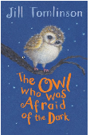  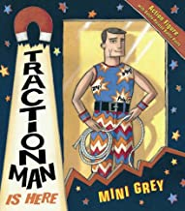  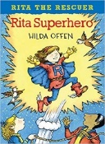 |  | 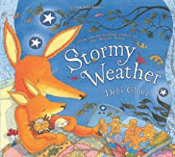  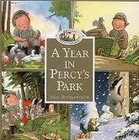 | 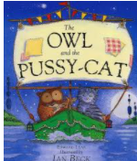  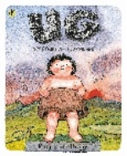  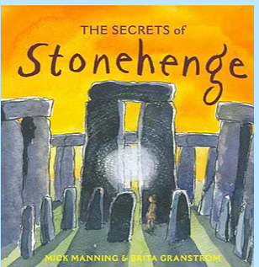 | 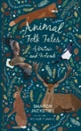  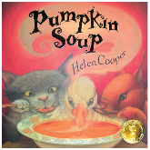 | 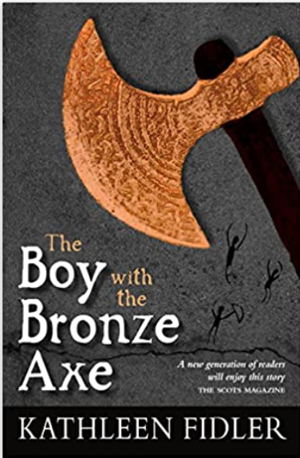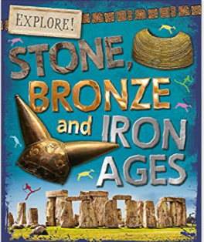 | 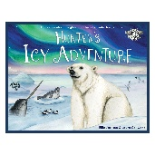  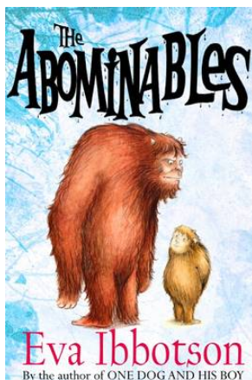
History / Geography | History: Who are our local heroes?  Lives of significant individuals |  | Geography: What are seasons?  Seasonal & daily weather; features of UK; maps & globes | History: How did life change during the Stone-Age? | Geography: Where does our food come from?  Study of small area of UK (SW region) | History: How did life change from the Stone-Age to the Iron Age? | Geography : Why is climate important?  Locate world’s countries; hot/cold countries/ climate zones
Science | Our Local Environment  (plants & animals) |  | Materials Monster  (materials) | Rocks, solids and fossils | Food and our bodies  (animals incl humans) | Light and shadows | Science in Action: Materials
Religious Education | What kind of world did (does) Jesus want?  Gospel: UC |  | Why does Advent (Christmas) matter to Christians?  Digging deeper: Incarnation UC | How special is the relationship that Jews have with God?  The covenant: Judaism D | Why does Easter matter to Christians?  Digging deeper | What is the best way for a Jew to show commitment to God?  Rites of passage: Judaism D | What was the impact of Pentecost? Kingdom of God:
PSHE | Being Me in my World |  | Celebrating Difference | Dreams and Goals | Healthy Me | Relationships | Changing me
Art / Design | Andy Warhol  Painting |  | DT | Famous Buildings  Sculpture | DT | Aboriginal Art  Drawing | DT
Sports Coach | Ball Skills  feet |  | Gymnastics:  linking | Invasion:  Bee Netball | Dance: Explorers | OAA: problem solving | Striking and fielding: cricket
Class Teacher PE | Gymnastics: symmetry and asymmetry |  | Ball Skills: hands 1 | Swimming | Invasion:  hockey | Net / Wall:  tennis | Athletics:  running
Computing | 3 week E-safety focus | We are astronauts  Programming on screen |  | We are programmers  Programming an  animation |  | We are bug fixers  Finding and correcting  bugs in programs | We are photographers  Taking better photos
Music | BBC Trailblazer: Vivaldi – ‘Winter’ |  | Music Express: Weather | BBC Teach John Adams: Short Ride in A Fast Machine | Notation & rhythm | Recorders | Recorders
Visitors/visits / other |  |  | Digital links with contacts in 4 countries of UK. | Trip to Stonehenge |  | Trip to Salisbury Museum | Kwik Cricket after school club/link to village CC

