 | Autumn 1 | Autumn 2 | Spring 1 | Spring 2 | Summer 1 | Summer 2
Book | 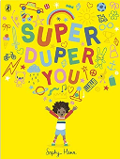  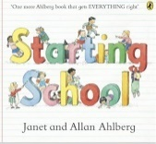  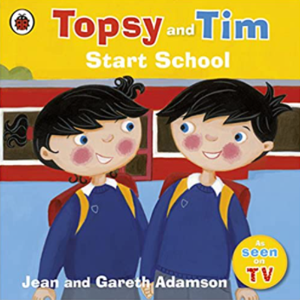 | 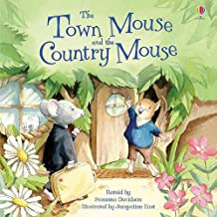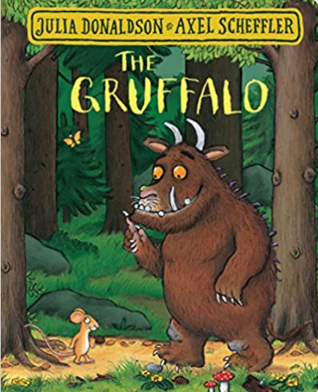 | 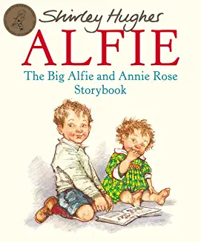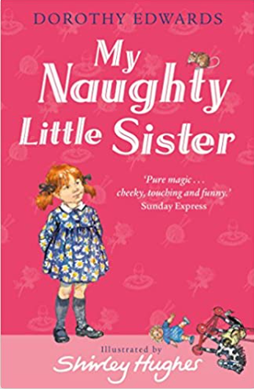 | 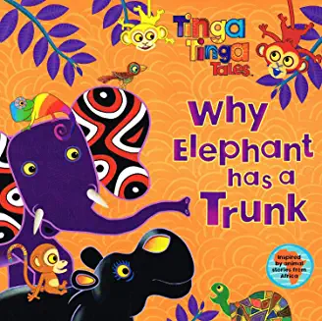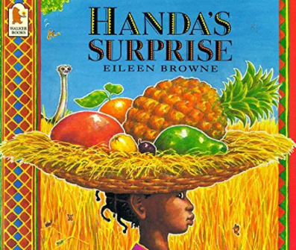 | 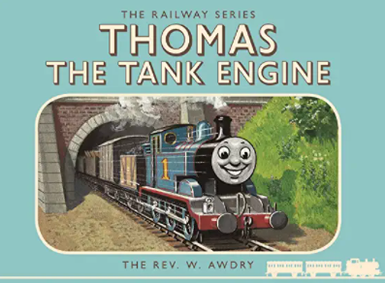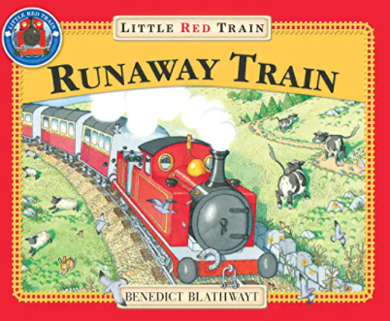 | 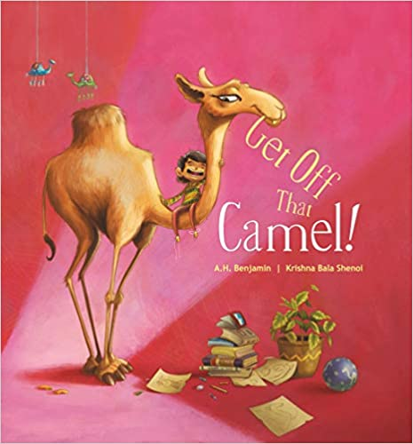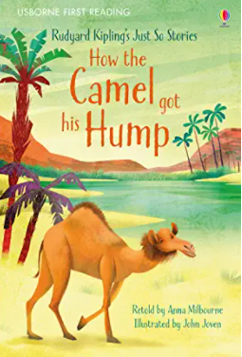
History / Geography |  | Geography: What’s it like in Heytesbury?  Local study | History: What was life like when my grandparents were children? (homes & school)  History within living memory | Geography: Where in the world do these people live? Small area of UK cf non-European country | History: How did Stephenson’s ‘Rocket’ change travel?  Events beyond living memory that are significant | Geography: Where do our favourite animals live? Hot & Cold places
Science | EYFS – Into the woods  Year 1  Plants where we live.( Identify and classify plants locally)  Seasonal change: Sept/Oct | Dough Babies – EYFS  Who am I (Body parts and senses)  Celebrations- food (structure of plants, edible bits) | EYFS –Pirates : floating and sinking, sorting  Y1 Materials – link to homes and history topic. | EYFS – Dinosaurs  Y1 Plants and animals where we live part 2 (birds and animal classification)  Seasonal change : March/April | EYFS – The potting shed  Y1 - Young gardeners Y2 subject knowledge ((How seeds and bulbs grow into mature plants. Pants need water, light and a suitable temperature to grow and stay healthy | EYFS - Food of the seasons  Y1 Healthy Me Y2 subject knowledge ( importance for humans of exercise, eating the right amounts of different types of food, and hygiene)  Seasonal change: July
Religious Education | What makes people special?  Special people: Christianity,  Judaism D | Why do Christians perform nativities at Christmas?  Incarnation UC | How do people celebrate?  Celebrations: Islam D | Why do Christians put a cross in an Easter garden?  Salvation UC | What can we learn from stories?  Islam, Judaism D | What is the good news that Jesus brings?  Gospel UC
PSHE | - Being Me in my World | Celebrating Difference | Dreams and Goals | Healthy Me | Relationships | Changing Me
Art / Design | Colour Creations  Painting |  | African Art  Painting |  | Henri Rousseau  Painting landscapes
Sports Coach  Complete PE | Gymnastics: moving | Locomotion  Jumping | Ball Skills  Hands | Dance The Zoo | Locomotion Dodging | Athletics  Running, jumping
Class Teacher PE  Complete PE | Locomotion:  Jumping | Gymnastics:  wide, narrow, curled | Dance Water | Ball Skills : feet | Swimming | Athletics  Throwing
Computing | We are treasure hunters  Using programmable toys | We are TV chefs  Filming the steps of a recipe | We are digital artists  Creating art inspired by artist | We are publishers  Finding images using the web | We are rhythmic  Producing a talking book with sound effects | We are detectives  Creating a greetings card digitally
Music | Music Express: Ourselves - singing | Songs for Christmas | BBC traditional tales: Anansi – singing; playing tuned & untuned instruments |  | Music Express Travel  Performance /beat | Singing
Visitors/visits / other | Rev Trudy: special people: Christianity  Walk around school field; river bank | Fieldwork in village  Christingle  Nativity | Grandparents | School nurse  Food tasting – unusual fruits | Visit to Steam Museum  Visit from Network Rail  School garden area planting | Whole school production

