Learning Project WEEK 1 - My Family
Age Range: Y3/4
Weekly Maths Tasks (Aim to do 1 per day) | Weekly Reading Tasks (Aim to do 1 per day)
- Work on set Mathletics tasks – these will be set each Monday for the week ahead.  - Play on Hit the Button - focus on number bonds, halves, doubles and times tables.  - Adding totals of the weekly shopping list or some work around money. This game could support work on adding money.  - Practise telling the time. This could be done through this game (scroll down to access the game). Y3: Read to the quarter hour and the nearest 5 minutes; Y4 practise all times.  - Practise counting forwards and backwards from any given number in 3s. Y4 also practise counting forwards and backwards in 4s. | - Listen to your child read a chapter from their guided reading book. Y3: Discuss together what you have read; Y4: read chpt 7. Answer questions on chpts 6 & 7 (already in books).  - Watch Newsround and discuss what is happening in the wider world.  - Get your child to read a book on Oxford Owls: https://www.oxfordowl.co.uk/for-home/find-a-book/library-page/ You will need to register for this but it is free.  - Explore new vocabulary you find when reading. What are the origins of this word? Can it be modified? Can you find any synonyms or antonyms for your new word?  - With your child, look in magazines, newspapers and books for new vocabulary they are unfamiliar with. They could use a highlighter to highlight in magazines and newspapers.
Weekly Spelling Tasks (Aim to do 1 per day) | Weekly Writing Tasks (Aim to do 1 per day)
- Practise 5 words from the Year 3/4 Common Exception words.  - Write a sentence for each of the 5 words to show you know what it means eg particular: I would like that particular bag because it has an inside pocket.  - Play a spelling game on Topmarks - https://www.topmarks.co.uk/english-games/7-11-years/spelling-and-grammar | - Write a recount of your day. This could be used in history one day to show what happened during this period.  - Write a character description of a member of their family. What do they look like? How do they behave? etc...  - Write a story involving members of their family. Do they have to defeat a monster? or find something they have lost?  - Write a letter/email/ text message to a member of their family that you have not seen this week.
Learning Project - to be done throughout the week
The project this week aims to provide opportunities for your child to gain a better understanding of their own family. Learning may focus on what different makeup of families, what traditions your family has, stories linked to your family etc.

- Let’s Wonder:

Who is in your child’s immediate family? What other relatives do they have? How does their family link together? How many people do they have in their family? Why not spend time looking through old photos and talking about the people in their families. What family stories can they tell? How is life different to their parents? grandparents?
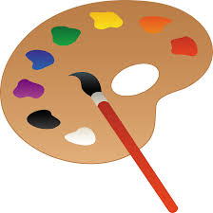
- Let’s Create:

Create a piece of artwork entitled ‘Family’. This could be a drawing, a self portrait, a sculpture or collage. Could they copy another artist's style? Which materials have they chosen to use and why? How do they feel about their piece of artwork? What would they change or not? Family portraits.

- Be Active:

Go Noodle with the family or have a family workout. Fancy a dance? There are lots of dance videos they could try. Dance. Maybe try some Yoga.
Recommendation at least 2 hours of exercise a week.

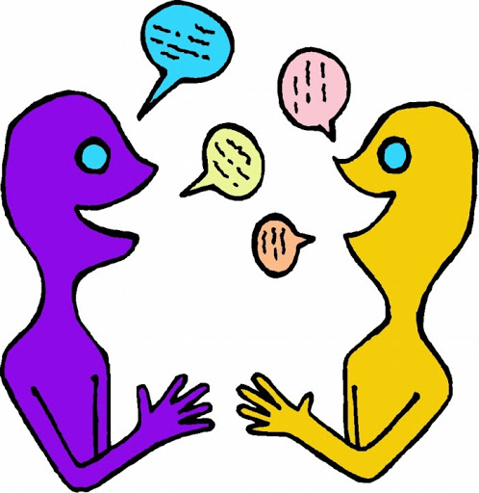
- Time to Talk:

Perhaps they could play a board game, facetime a member of their family they have not seen this week, enjoy a family indoor picnic or have a family dinner.

- Understanding Others and Appreciating Differences:

Discuss how their family is different to other people’s families. Discuss whether all families are the same? Does it matter? Do all families have the same faith? Do all families worship in the same way?

- Reflect:
Find out what music their family members enjoy. Do they like the same music? What is their favourite song? They could listen to different pieces of music together with their family. Do they like/dislike any particular types of music and why? Can they Identify the instruments they can hear and describe how the music makes them feel? Why not get them to listen to some of the classics?

