Our Topic is:
“What’s it made of?
Our Christian value this term is:
Friendship
EYFS  Communication and Language (CL)  Literacy  Year 1  English | - Our Texts  - Pigs might fly  - Jack and the Jellybeanstalk  - Collecting action, noisy and feeling vocabulary  - Saying sentences containing words from our collections  - Retelling the story of pigs might fly and Jack and the jelly beanstalk  - Listening to and discussing a range of traditional tales including different versions of “The three Little Pigs” and “Jack and the Beanstalk”  Listening to and responding to Our Growth Mindset texts  Little by Little – Amber Stuart, Bears Don't Read-Emma Chichester Clark, The Dinosaur Who Lost Her Voice- Julie Ballard & Francesca Gambatesa, Girrafes can’t dance, Almost Anything-Sophie Henn  EYFS  - Using vocabulary from our word collections in play.  - Read the graphemes ai ee igh oa oo oo ar ur ow oi ear air er  - Read words with double letters: dd mm tt bb rr gg pp ff  - Read tricky words or was you they my by all  Year 1  Reading and Spelling patterns in words containing these graphemes  - /ee/ y funny /e/ ea head /w/ wh wheel /oa/ oe ou toe shoulder  - /igh/ y fly /oa/ ow snow /j/ g giant /f/ ph phone  - /l/ le al apple metal /s/ c ice /v/ ve give  - /u/ o-e o ou some mother young /z/ se cheese /s/ se ce mouse fence /ee/ ey donkey
EYFS  Personal Social Emotional Development (PSED)  Year 1  Personal, social, health and economic education | Our jigsaw topic is: Goals and Dreams  We will also be:  - Revisiting class rules and routines.  - Learning about growth mindset through reading books.
EYFS - Physical Development (PD)  Year 1 - Physical Education | Improving our fine motor skills for using tools, being creative and writing.  In PE we will focus on:  Dance: Water  Ball Skills - Hands
EYFS  Mathematics  Year 1  Mathematics | - Count the objects in two groups to find the total  - Find the number that is one more or one fewer than a given number without counting  - Addition within 10, beginning to count on  - Subtraction within 10, beginning to count back  - Compare and order two weights by direct comparison  - represent and use number bonds and related subtraction facts within 20  - solve one-step problems that involve addition and subtraction, using concrete objects and pictorial representations, and missing number problems such as 7 = ? – 9  - count to and across 100, forwards and backwards, beginning with 0 or 1, or from any given number  recognise and know the value of different denominations of coins and notes  - read, write and interpret mathematical statements involving addition (+), subtraction (–) and equals (=) signs  - add and subtract one-digit and two-digit numbers to 20, including 0  - Use pictorial representations to solve subtraction problems.  - add and subtract one-digit and two-digit numbers to 20, including 0  - recognise, find and name a half as 1 of 2 equal parts of an object, shape or quantity  - recognise, find and name a quarter as 1 of 4 equal parts of an object, shape or quantity

EYFS  Understanding the World (UW)  Year 1  History  Science | What were homes and schools like in the 1950s and 60s?  Naming types of materials used for building homes.  Floating and sinking.  Water and ice.  Which materials would we use to build a waterproof den?  Year 1 only  Sorting materials based on their properties.
EYFS  Expressive Arts and Design (EAD)  Year 1  Design Technology  Music | Constructing for role play  Singing songs linked to friendship.  Designing houses for the three little pigs.
Religious Education | How do people celebrate?

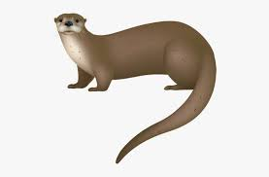

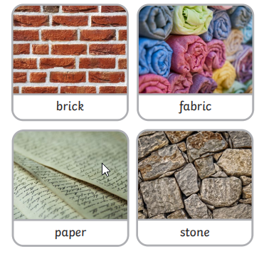
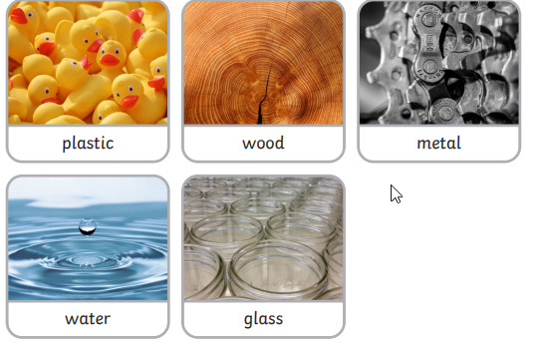
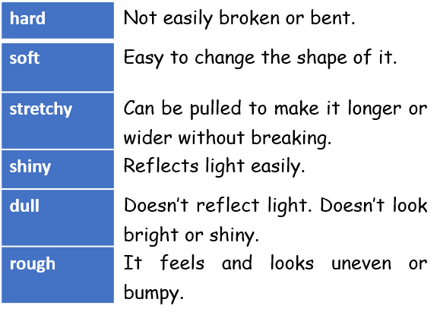
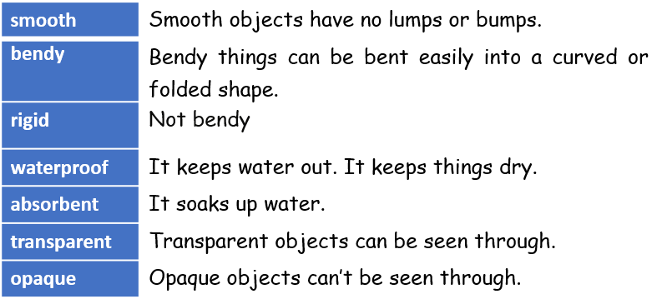
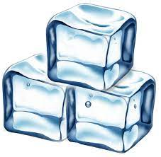

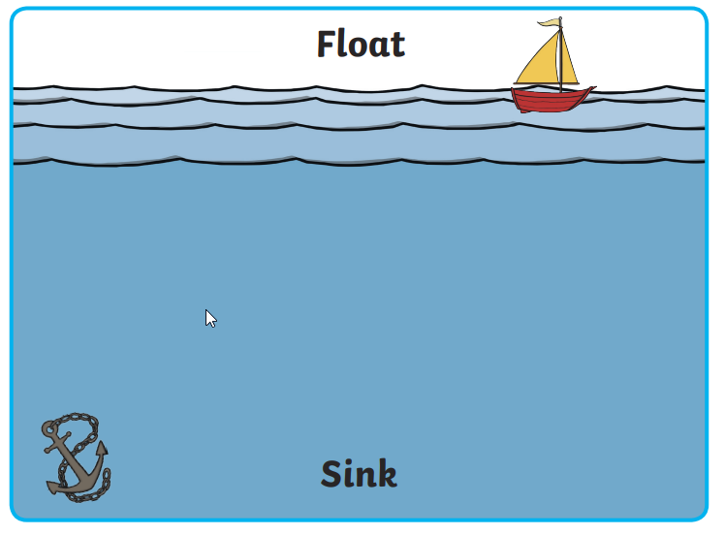
Science - Every day materials Topic – Builders Otter Class
Materials are what an object is made of.
Solid – stays the same 3D shape.
Liquid – pours or runs.
Reading Books
Reading books will be changed on a Monday. Please hear your child read each night and complete the activities on the inside of the back/front cover of their reading books, Please recording reading in Heytesbury reading record books so we know your child needs a new reading book.
Sharing books – these are picture books from the class library, please read these to your child and talk about the story.

Homework Year 1 only
Spellings:
New spellings are given on a Monday and tested the following Friday ,
Mathletics
Practise 2 or 3 times a week.
Mathletic log in will be stuck into the inside cover of reading records.

Homework EYFS only

Children should practise getting dressed/undressed independently.
Children to put on their own coat, shoes and jumper (and take them off).
Practise using cutlery – knife, fork and spoon when eating.

PE
- PE is on a Thursday and Friday in Otters class.
- All children need PE kit in school every day.
- kit required – school PE t-shirt, school shorts, trainers, As the weather cools, if so wished - plain black joggers or plain black sport leggings, school sweat shirt or hoodie, Girls will need socks - tights are not allowed to be worn under shorts,
- Please can children have a change of clothing in book bags in-case of accidents,

Extra Information
Otters Staff
- Mrs Fulop teaches all day Monday, Tuesday, Wednesday and Thursday morning. (Year 1 children are learning Maths each day from 9-10 am with Mr Foyle)

- Miss Graham teaches Thursday 2pm-3:15pm and from 10am on Friday

- Mrs Vincent and Mrs Greeway are our class Teaching Assistants.

- An Acorn Trust Sport coach teaches PE on Thursdays 1pm-2pm.

